Australia Act Fraud! 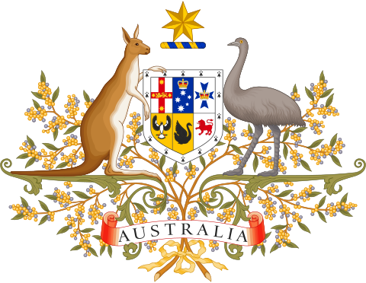

Australia Act Fraud Detailed

ELECTION FRAUD IN AUSTRALIA
ALL ELECTORS IN AUSTRALIA AND ALL AUSTRALIANS ARE VICTIMS OF THE FRAUD OF THE AUSTRALIA ACT 1986

- The following 10 facts of Fraud of the Australia Act 1986 have not been rebutted and therefore they remain facts.
- These material facts show that Australian Law emanating from the fraudulent Australia Act 1986 is based on fraud and therefore no law at all.
- The difference is between the Constitution of the Commonwealth of Australia and the CORPORATION OF THE COMMONWEALTH OF AUSTRALIA.
The Commonwealth Constitution Act 1901 was granted to the people by Queen Victoria.
The CORPORATION is the ruling entity that owns, runs and controls the CITY OF LONDON which is not subject to, nor under any law of the Monarch of England
This is the First Fraud
Prior to Federation in 1900 Australia was divided into Colonies, after Federation the Colonies became States, but each State was subject to the Constitution.
Prior to the fraudulent 1986 AUSTRALIA ACT any bill either State or Commonwealth touching a Constitutional issue had to be reserved for Royal Assent involving the Two Houses of Parliament back in England in the process, and then it must be ratified and accepted by the People of the Commonwealth of Australia voting in a referendum. No referendum = TREASON.
By 1984 the International Socialist movement, specifically the Fabian Socialists, had succeeded in getting Mr Robert Hawke elected as Prime Minster of Australia. He then proceeded to “enact” the Australia Act. However, HM Queen Elizabeth 2 of the UK did not sign the Act. Instead, she placed her initials at the top right of the first page to indicate that the Act was subject to a referendum of the People of the Commonwealth of Australia. No referendum has ever been held. = TREASON.
The Second Fraud
In a 1996 Senate Standing Committee paper titled “Aspects of Section 44” Professor Blackshield submitted a paper to the committee which stated that Mr Hawke may have a case to answer in relation to Section 44 of the Commonwealth Constitution Act 1900 in that at the time of being Prime Minister Bob Hawke was also an Honorary Citizen of Israel. (Duel Citizenship)
The Third Fraud
Prior to the actual enactment of the Australia Act 1986 new “Letters Patent” were issued, it appears that the signature to the new Letters Patent signed at Balmoral in Scotland in 1984 was Mr R Hawke…Not HM Queen Elizabeth II.
The Fourth Fraud
To avoid having to send the 1986 Australia Act to the governed via a Constitutional Referendum, Mr Hawke and the Six Premiers involved decided to use section 51 (xxxviii) of the Commonwealth Constitution instead to make it law. The Australia Act sought to change the terms of the Constitution. Therefore, any changes to it without a referendum make the Australia Act null and void
Powers of the Parliament
51. The Parliament shall, subject to this Constitution, have power to make laws for the peace, order, and good government of the Commonwealth with respect to:-
(xxxvii.) Matters referred to the Parliament of the Commonwealth by the Parliament or Parliaments of any State or States, but so that the law shall extend only to States by whose Parliaments the matter is referred, or which afterwards adopt the law:
The Fifth Fraud
By using Section 51 and not Section 128 this activated the State Request Acts. As such, under their State Constitutions, Elector approval had to be sought prior to any Royal Assent being granted. (A referendum is required.)
The Sixth Fraud
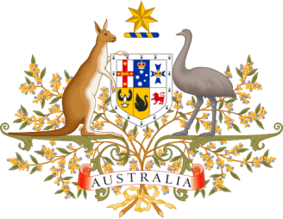
In Western Australia, section 73 of their State Constitution
(2) A Bill that —
(e) expressly or impliedly in any way affects any of the following sections of this Act, namely — sections 2, 3, 4, 50, 51 and 73, shall not be presented for assent by or in the name of the Queen unless —
(g) the Bill has also prior to such presentation been approved by the electors in accordance with this section, and a Bill assented to consequent upon its presentation in contravention of this subsection shall be of no effect as an Act. (A referendum is required.)
In Queensland, section 53 of their State Constitution
53.(1) A Bill that expressly or impliedly provides for the abolition of or alteration in the office of Governor or that expressly or impliedly in any way affects any of the following sections of this Act namely— sections
1, 2, 2A, 11A, 11B; and this section 53 shall not be presented for assent by or in the name of the Queen unless it has first been approved by the electors in accordance with this section and a Bill so assented to consequent upon its presentation in contravention of this subsection shall be of no effect as an Act. (A referendum is required.)
In New South Wales, section 7 of their State Constitution
7(a) (2) A Bill for any purpose within subsection (1) shall not be presented to the Governor for His Majesty’s assent until the Bill has been approved by the electors in accordance with this section.
7(b) shall not be presented to the Governor for Her Majesty’s assent until the Bill has been approved by the electors in accordance with this section. (A referendum is required.)
The Seventh Fraud
Within the Australia Act 1986 section 14 amends the Western Australian Constitution by amending section 50 and 51, but these particular sections are bound to elector consent and approval at section 73 of the Western Australia Constitution. (A referendum is required.)
The Eighth Fraud
Within the Australia Act 1986 section 13 amends the Queensland Constitution by amending section 11A and 11B, but, these particular sections are bound to elector consent and approval at section 53 of the Queensland Constitution. (A referendum is required.)
The Ninth Fraud
After the purported enactment of the Australia Act 1986 “Reservation of Bills” for Royal Assent stopped and Royal Assent to Constitutional amendments operated within Australia after 1986 without any knowledge of the electorate, that “Primary Fraud” had occurred in relation to The Constitution of the Commonwealth of Australia as opposed to the CORPORATION OF THE COMMONWEALTH OF AUSTRALIA operating via the CORPORATION OF THE CITY OF LONDON.
The Tenth Fraud
The due process of law was not followed in any State or Territory when the State Requests Acts 1985 were purportedly enacted in 1985. (A referendum is required.)
This is all evidence that shows that Australian Law emanating from the fraudulent Australia Act 1986 is based on fraud and therefore no law at all.
