Mr Mark McGowan
Shop 13, The Boardwalk
7 Railway Terrace
Rockingham WA 6168
mark.mcgowan@mp.wa.gov.au

Dear Mr McGowan

RE: ELETORAL FRAUD AND MISPRISION OF TREASON

I am writing to inform you of a letter I wrote to Mr Kennedy, the ELECTORAL COMMISSIONER in response to an Apparent Failure to Vote - Penalty Notice dated 2nd July 2021 issued by him (natural person). He committed mail fraud due to signing the letter after I received the said letter but he also did attempt to obtain financial advantage by deception.

My valid reason for not voting in the 13th March 2021 Western Australian state Election that it was a FRAUDULANT ELECTION. I also have evidence that a crime of misprision of treason has been committed.

As you are well aware, the foundation of an election being called is based on an election writ being issued by the Western Australian State Governor. The current alleged Western Australian State Governor Kim Beazley allegedly represents the Queen to give this alleged grant of power.

In 2003-2004, the Crown, Queen Elizabeth II as well as her heirs and successors were removed from Western Australia. The offending treasonous act was the Acts Amendment and repeal (Court and Legal Practice) Act 2003, section 8, enacted in 2004. John Sanderson (natural person) the alleged Western Australian State Governor at the time made himself the monarch of Western. His co-collaborators/co-conspiritors were, Jim McGinty the alleged Western Australian Attorney General, (natural person) and the Western Australian Parliament.

This particular act also illegally added the commonwealth in this act.

ACTS AMENDMENT AND REPEAL (COURTS AND LEGAL PRACTICE) ACT 2003 (NO. 65 OF 2003) - SECT 123

123 . The Criminal Code amended
(1) The amendments in this section are to The Criminal Code *.
[* Reprinted as at 9 February 2001 as the Schedule to the Criminal Code appearing as Appendix B to the Criminal Code Compilation Act 1913.
For subsequent amendments see 2001 Index to Legislation of Western Australia, Table 1, p. 89 and Acts Nos. 3, 6, 8 and 27 of 2002. ]
(2) Each of the provisions in the Table to this subsection is amended by deleting “Crown” in each place where it occurs and in each case inserting instead —
“ prosecutor ”.
(3) Section 581 is amended by deleting “Crown” in the 2 places where it occurs and in each place inserting instead —
“ State ”.
(4) Section 584(14) is amended by deleting “Her Majesty” and inserting instead —

“ the State ”.
(5) Section 609 is amended by deleting “Crown” and inserting instead —
“ State or the Commonwealth ”.
(6) Section 628 is amended as follows:
(a) by deleting “Crown” in the first and third places where it occurs and in each place inserting instead —
“ prosecutor ”;
(b) in paragraph (2) by deleting “Crown” and inserting instead —
“ State or the Commonwealth, as the case may be, ”.
(7) Section 633 is amended by deleting “Crown” and inserting instead —
“ State or the Commonwealth, as the case may be, ”.
(8) Section 637 is amended by deleting “counsel for the Crown” in the 4 places where it occurs and in each place inserting instead —
“ prosecutor ”.
(9) Section 693A(4) is amended by deleting “Crown” and inserting instead —
“ State ”.
(10) Section 701(2) is amended by deleting “for the Crown thereon”.
(11) Section 720 is amended by deleting “Queen” and inserting instead —
“ State ”.
(12) Section 729(3) is amended by deleting “Crown” in the 3 places where it occurs and in each place inserting instead —
“ prosecution ”.
(13) Section 746A(1) is amended as follows:
(a) by deleting “prosecution” and inserting instead —
“ State ”;
(b) by deleting “Crown” and inserting instead —
“ State ”.
(14) Section 746A(4) is amended by deleting “Crown” and inserting instead —
“ State ”.

130. Supreme Court Act 1935 amended
(1) The amendments in this section are to the Supreme Court Act 1935*.
[* Reprinted as at 9 February 2001.
For subsequent amendments see 2001 Index to Legislation of Western Australia, Table 1, p. 370 and Act No. 23 of 2002.]
(2) Section 4 is amended as follows:
(a) in the definition of “Action” by deleting “by the Crown”;
(b) in the definition of “Cause” by deleting “by the Crown”.
(3) Section 9(1) is amended by deleting “Her Majesty” and inserting instead —
“ the Governor ”.
(4) Section 15(1) is amended by deleting “Royal Arms” and inserting instead —
“ armorial bearings of the State ”.
(5) Section 37(2) is repealed and the following subsection is inserted instead — “
(2) Nothing in this section shall alter the practice in proceedings in relation to the prerogative and criminal jurisdiction of the Court.”.
(6) Section 50(1) is amended by deleting “by the Crown”.
(7) Section 51(1) is amended by deleting “by the Crown”.
(8) Section 56(1) is amended by deleting “by the Crown”
(9) Section 119 is amended by deleting “to Her Majesty or any of her subjects, or other persons entitled in like manner as subjects”.
(10) Section 154(1) is amended by deleting “Her Majesty’s” and inserting instead —
“ The ”.
(11) Section 154(3), (4), (5) and (6) are each amended by deleting “Crown” in each place where it occurs and in each place inserting instead.

The Constitution Act of Western Australia (UK) section 12 states; for the purpose of constituting the Legislative Assembly, the Governor before the time appointed for the first meeting of the Legislative Council and Legislative Assembly, and thereafter from time to time as occasion shall require, may in Her Majesty's name issue writs under the public seal of the Colony for general election of members to serve in the Legislative Assembly.

I am saying in this correspondence that the writ issued is fraudulent, illegally issued by a person (Kim Beasley) still pending a grand jury process in Melbourne.

Furthermore our current alleged Western Australian Governor, Kim Beazley has been criminally charged with misprision of treason by Brian Shaw (private prosecution). This was witnessed by Gerard Donohue. Brian shaw was contacted by a barrister by the name of Robert Richter QC (Queens Counsel), representing Kim Beazley on the 15th December 2006. The misprision of treason charge has been concealed and ignored.

I have knowledge that a writ is about to be issued relative to this Fraudulent election. In due course this writ will be served at the state solicitors office.

Please provide me with a copy of the two election writs issued by the alleged Western Australian Governor. I was unable to locate the two Western Australian State election writs on the official Electoral Commission website: https://www.elections.wa.gov.au. I have also requested this information via email with no reply. As the alleged Western Australian Premier, you and the labor party are the beneficiaries of the two fraudulent election writs. The foundation of the Western Australian State Election hinges on these documents.

If these documents are fraudulent then you nor your cabinet have no more authority to declare a state of emergency, issue mandates, fines, mandatory vaccines, lockdowns than a Coles checkout chick.

The 13th March 2021 election results were called after only 0.7% of the votes were counted.

Furthermore, I refer to the Hansard script dated 22nd March 1978 ACTS AMENDMENT (CONSTITUTION) BILL Second Reading SIR CHARLES COURT (Nedlands-Premier):

"I Sir CHARLES COURT: The principles espoused in this Bill are so important that the Government has decided to reintroduce the Bill as it is part of our policy statement made to the 307 308 [ASSEMBLY) electors for the period 1977-1980."

"That statement contained the following quote referring to any attempt to damage or destroy the status of the Parliament of Western Australia. I again quote from that policy statement as follows-- We will legislate to block any further attempt to damage or destroy the rights and status of the Parliament of Western Australia, without the consent of the people."

"This policy stems from a series of Australian Labor Party moves culminating last year in a decision of the State A.L.P. Conference that a future Labor Government would not appoint State Governors. Quite rightly-then and now-we have interpreted this decision as part of the long-term Labor Party goal of destroying State Parliament in the interests of centralising all Government in Canberra."

"I am quoting from the document, which continues We therefore give notice that our intended legislation to block such moves without the people's consent is a policy proposal for which we seek a clear-cut mandate from electors."

" Our proposed legislation will protect and preserve both Houses of our State Parliament, and with them the office of Governor. We have reason to believe that attempts could be made to abolish either or both Houses of Parliament, reduce the numbers of the members of either House in an attempt to weaken them, or to by-pass the right of the electors at large to elect the members of either House."

"To continue, we also have reason to believe that attempts could be made to alter the office of Governor, to abolish or water down the right of the Queen to appoint the Governor, to by-pass the Governor's role in giving assent to every law, or to make the Governor a rubber stamp of the Government as part of the process of undermining our State Constitution and our Parliament."

" To protect Parliament-our legislation will provide that no changes of the nature mentioned, can be made concerning either House of Parliament without the approval of a majority of the State's electors at a referendum. "

"To protect the position of Governor-there would have to be similar approval by referendum to any Bill which would abolish or alter the office of Governor, or the Queen's sole right to appoint the Governor or issue instructions with which the Governor must comply in performing his duties, or which would alter the requirement that the Governor's assent must be given to every Bill before it becomes law. This means that unless the people agree otherwise, the Governor's role will continue exactly as it is and will be protected from political manipulation."

"The major role of the Governor is to ensure that not even Parliament can exceed the authority the people give it."

And herein the problem lies, AUSTRALIAN LABOR PARTY (WA BRANCH) is a privately owned political party/corporation with an ABN number of 99 279 642 391. It is a business entity categorised as 'OTHER UNINCORPORATED ENTITY' which is defined as a number of people grouped together by a common purpose with club-like characteristics, for example, a sporting club, social club or trade union.
Some club-like characteristics are that:
- there are members of the association
- the members will normally be free to join or leave the association
- the association will normally continue in existence independently of any change to the composition of the association
- as a matter of history, there will have been a moment in time when a number of persons combined to form the association.
- there is a contract (which can fall short of a legally enforceable contract) binding the members among themselves, and
- there is a constitutional arrangement for meetings of members and for appointing officers.
- The meaning of any other unincorporated association or body of persons does not include a non-entity joint venture.
As a PRIVATE POLITICAL ENTITY, in other words 'a club' only members of this party can vote. Most of the Western Australian population are not members of this club so therefore they are not required to vote further cementing the fact that you have committed ELECTORAL FRAUD. The Labor party was eminated and founded on the principles of the Fabian Socialism.

Sir Charles Court warned Western Australian of this.
He also goes on to say: " If Parliament does so, the Governor can send it back to the people, who have the ultimate authority. We reject the misconception fostered by the A.L.P.-that the Governor has some kind of power over the people which he should not have. In fact, he merely has constitutional authority for and on behalf of the people. This authority has never been used, but the fact that it remains in reserve is a powerful safeguard against abuse by a government of the rights of the people."

In the interest of transparency I have no political affiliations or agenda.

Mr Beazley our alleged Western Australian Governor is not safe guarding 'we the people' of Western Australia he is conspiring with the Labor party in treason. The security legislation defines treason:

4.3 The Act moved the offence of treason from the Crimes Act 1914 into the Criminal Code, replaced the death penalty with life imprisonment; and removed gender specific references to the sovereign.

4.4 Under section 80.1 a person commits treason if he or she:
- causes the death or harm, resulting in death, imprisons or restrains the Sovereign, the heir apparent of the Sovereign, the consort of the Sovereign, the Governor-General or Prime Minister
- levies war, or does an act preparatory to levying war against the Commonwealth
- intentionally assists, by any means whatsoever, an enemy, at war with the Commonwealth
- intentionally assists, by 'any means whatever', another country or organisation that is 'engaged in armed hostilities' against the Australian Defence Force (ADF)
- instigates a person who is not an Australian citizen to make an armed invasion of the Commonwealth or a Territory of the Commonwealth, or
- forms an intention to do any of the above acts and manifests that intention by an overt act.

https://www.aph.gov.au/Parliamentary_Business/Committees/Joint/Completed_Inquiries/pjcis/securityleg/report/chapter4
Continuing on "The Bill seeks to achieve three purposes.
The first is to emphasise the role of Her Majesty the Queen in the Parliament of Western Australia."

Queen Elizabeth II along with here heirs and successors were removed from Western Australia in 2003-2004. As mentioned earlier the offending treasonous act was the Acts Amendment and repeal (Court and Legal Practice) Act 2003, section 8, enacted in 2004.

The second is to protect and preserve the existence of both Houses of the State Parliament and to ensure their continued role as an integral and essential part of the law-making process.

The third purpose of the Bill is to confirm by Statute the office of the role of Governor, and that appointments to the office of Governor and the instructions with which the Governor must comply in performing his duties are both made and issued by the Queen personally, as happens at present.

Mr Beazley the alleged Governor General has no line of authority as there is no letters patent. Again, Queen Elizabeth II along with her heirs and successors were removed from WA in the Acts Amendment and repeal (Court and Legal Practice) Act 2003, section 8, enacted in 2004.

Sir Charles Court continues "The Bill proposes to spell out clearly in our Constitution the fact that our Parliament consists of the Queen and the Legislative Council and the Legislative Assembly. The Bill also proposes that any future Bill which would abolish either House of the Parliament, or which would reduce the numbers of members 308 [Wednesday, 22nd March, 1978]30 of either House, or- which would permit either House to be constituted by members not elected by the electors at large can become law only if such a Bill is passed by an absolute majority of both Houses of Parliament and is approved of by all of the electors of the State voting at a referendum. The referendum would have to be held not less than two months and not later than six months after the passage of the relevant Bill through both Houses of Parliament."

"Here I would like to emphasise that this is slightly different from the wording of last year's Bill, the limiting periods being similar to those provided for Commonwealth referendums. It will be recalled that a query was raised last time the legislation was before the House as to why there was no limit on the time during which the referendum could be held."

Mr Davies: You suggested then that a Government might not go on with the referendum."

There is no referendum in Western Australia on the public record to remove the Crown?

In 1999 there was a referendum to alter the Constitution to establish the Commonwealth of Australia as a republic with the Queen and Governor-General being replaced by a President appointed by a two-thirds majority of the members of the Commonwealth Parliament. And to alter the Constitution to insert a preamble and the people voted NO.

" We were queried as to why we did not have a limitation. At the time, quite frankly, I was not very concerned about it, and now I am still not; but if it does make it tidier so we are precise about the minimum and maximum times, we felt it would be wise to include the six months, particularly as it has a relativity with Commonwealth referendums."

"The same procedure would also apply to any Bill which would abolish or alter the office of Governor, abolish or alter the sole right of the Queen to issue instructions to the Governor as to the performance of his duties, or alter the requirement that every Bill must be presented to the Governor for assent before it may become law. The proposed Bill, in so far as it deals with the office, obligations, and powers of the Governor, makes no change in long-standing constitutional conventions and practices, but is intended to ensure that those long-standing conventions and practices cannot in the future be altered without the consent of a majority of the electors of the State."

" A reference to the Governor includes any other person properly appointed to administer the Government or exercise any powers or authorities during his temporary absence. When I introduced a similar Bill last year I made a particular point of emphasising the role of the Governor and it is worth repeating again. The major role of the Governor is to ensure that not even Parliament can exceed the authority given to it by the people."

" If any alteration to the Parliament or any part of its operation which affects the role of the Houses or the role of the Governor is to be contemplated, then it is only right that the people should be consulted. They are, after all, the ultimate authority for each member in these Houses of Parliament and I will mourn the day when that is no longer the case. The principles in this Bill are simple and are designed to give the people in Western Australia stability in Government and security for the future. I commend the Bill to the House. Debate adjourned, on motion by Mr Davies (Leader of the Opposition)."

Mr McGowan, I have written to you before issuing you personally with a NOTICE OF LIABILITY TO COMMITTING MALFEASANCE. You ignored this notice so in the interest of thoroughness here is the contents of my correspondence. I sent this in February 2021.

Dear Mr McGowan

I do not consent to mandating the quarantine of healthy people, mask wearing, contact tracing, PCR testing and Covid-19 Vaccinations, excessive fines and forced medical procedures. It is a directive (not law) and you are responsible for this mandate.

You are breaching your ‘duty of care’ towards mySELF as a West Australian. I am putting you on notice, I do not consent to any procedure to be conducted on my body with lack of sufficient information, evidence and knowledge of the complete efficacy and all adverse events related to them. This does not meet the requirement of full disclosure and is a crime of battery. You are breaching your ‘duty of care’ for me as a West Australian.

THIS IS A CRIME OF MALFEASANCE, WHICH YOU ARE PERSONALLY LIABLE FOR.
You have authorised the closure of the Western Australian boarders under a state of emergency, you have forced healthy Western Australians to be quarantined and subjected them to asymptomatic Covid-19 testing, you have mandated the wearing of masks depriving our community of the right to breathe fresh air. You have personally traumatised the population of Western Australia through medical tyranny subjecting them to mental and emotional trauma caused by your actions because one person may have tested positive with Covid-19.

The Western Australian Government is a private corporation trading as the WESTERN AUSTRALIAN TREAURY CORPORATION with an ABN: 22 300 359 323. the COMMONWEALTH OF AUSTRALIA ABN 122 104 616 and registered with the United States American Securities and Exchange Commission: No. 000 080 5157. 651 and it’s CIK# is 0000805157. The business address is listed as 1601 MASSACHUSETTS AVE NWC/O AUSTRALIAN EMBASSY WASHINGTON DC 20036.

UNIVERSAL DECLARATION OF HUMAN RIGHTS
Article 3: Everyone has the right to life, liberty and the security of person. (OXYGEN IS LIFE)
Article 5: No one shall be subjected to torture or to cruel, inhuman or degrading treatment or punishment.
FORCING PEOPLE TO WEAR MASKS IS CRUEL, INHUMANE, AND DEGRADING.

Article 19: Everyone has the right to freedom of opinion and expression; this right includes freedom to hold opinions without interference and to seek, receive and impart information and ideas through any media and regardless of frontiers. MY BODY MY CHOICE.

INTERNATIONAL COVENANT ON CIVIL AND POLITICAL RIGHTS
Article 1:
All peoples have the right of self-determination. By virtue of that right they freely determine their political status and freely pursue their economic, social and cultural development.

THIS LOCK DOWN IS A BREACH OF CIVIL RIGHTS!
Article 7
No one shall be subjected to torture or to cruel, inhuman or degrading treatment or punishment. In particular, no one shall be subjected without his free consent to medical or scientific experimentation.

VACCINES EXPERIMENTS, NO JAB NO PAY OR PLAY AND ENFORCED MASK WEARING IS A CLEAR BREACH OF THE INTERNATIONAL COVENANT ON CIVIL AND POLITICAL RIGHTS.
Article 9
1. Everyone has the right to liberty and security of person. No one shall be subjected to arbitrary arrest or detention. No one shall be deprived of his liberty except on such grounds and in accordance with such procedure as are established by law.
5. Anyone who has been the victim of unlawful arrest or detention shall have an enforceable right to compensation. QUARANTINE AND HOUSE ARRESTS ARE BREACHING OUR CIVIL RIGHTS!
Article 11
No one shall be imprisoned merely on the ground of inability to fulfil a contractual obligation.
BREACHING LOCKDOWN AND GETTING ARRESTED IS A BREACH OF OUR CIVIL RIGHTS!

Article 12
1. Everyone lawfully within the territory of a State shall, within that territory, have the right to liberty of movement and freedom to choose his residence.
2. Everyone shall be free to leave any country, including his own.
3. The above-mentioned rights shall not be subject to any restrictions except those which are provided by law, are necessary to protect national security, public order (ordre public), public health or morals or the rights and freedoms of others, and are consistent with the other rights recognized in the present Covenant.
4. No one shall be arbitrarily deprived of the right to enter his own country.
CLOSING THE BORDERS IS BREACHING OUR CIVIL RIGHTS!

Article 17
1. No one shall be subjected to arbitrary or unlawful interference with his privacy, family, home or correspondence, nor to unlawful attacks on his honour and reputation.
2. Everyone has the right to the protection of the law against such interference or attacks.
FORCED CONTACT TRACING!!!!

Article 20
1. Any propaganda for war shall be prohibited by law.
2. Any advocacy of national, racial or religious hatred that constitutes incitement to discrimination, hostility or violence shall be prohibited by law.
COVID IS WAR PROPOGANDA – WAR ON AUSTRALIANS!

The Nuremberg Code (1947)
Permissible Medical Experiments
The great weight of the evidence before us to effect that certain types of medical experiments on human beings, when kept within reasonably well-defined bounds, conform to the ethics of the medical profession generally. The protagonists of the practice of human experimentation justify their views on the basis that such experiments yield results for the good of society that are unprocurable by other methods or means of study. All agree, however, that certain basic principles must be observed in order to satisfy moral, ethical and legal concepts:
The voluntary consent of the human subject is absolutely essential. This means that the person involved should have legal capacity to give consent; should be so situated as to be able to exercise free power of choice, without the intervention of any element of force, fraud, deceit, duress, overreaching, or other ulterior form of constraint or coercion; and should have sufficient knowledge and comprehension of the elements of the subject matter involved as to enable him to make an understanding and enlightened decision.

Public Health Act 2016
158.Enforcement of requirement to undergo medical observation, medical examination
(1)If an authorised officer gives a direction to a person under section 157(1)(j) to undergo medical observation, medical examination or medical treatment or to be vaccinated, an authorised officer or police officer may use reasonable force to ensure that the direction is complied with, including, if necessary —

(a)to apprehend and detain the person to whom the direction applies (the relevant person) and take the relevant person to a place where the person is required to undergo medical observation, medical examination or medical treatment or to be vaccinated in accordance with the direction; and
(b)to detain the relevant person at the place where he or she is required to undergo medical observation, medical examination or medical treatment or to be vaccinated in accordance with the direction; and
(c)to restrain the relevant person —
(i)to enable a medical observation, medical examination or medical treatment to be carried out; or
(ii)to enable the relevant person to be vaccinated;
and
(d)to remove anything (including underwear) that the relevant person is wearing, if —
(i)the removal of the thing is reasonably necessary to enable a medical examination or medical treatment to be carried out or, as the case requires, to enable the person to be vaccinated; and
(ii)the relevant person is given a reasonable opportunity to remove the thing himself or herself, and refuses or fails to do so.

(2)A direction under section 157(1)(j) to undergo medical examination or medical treatment or to be vaccinated authorises —
(a)in the case of a direction to undergo medical examination —
(i)the carrying out of that medical examination in accordance with the direction; and
(ii)the testing of any sample obtained or taken in connection with that medical examination; and
(b)in the case of a direction to undergo medical treatment —
(i)the giving of medical treatment to the relevant person in accordance with the direction; and
(ii)the testing of any sample obtained or taken in connection with that medical treatment; and
(c)in the case of a direction to be vaccinated, the vaccination of the relevant person.

(3)If any action taken under subsection (1) involves the removal of an item of clothing —
(a)it must be done with decency and sensitivity and in a manner that gives to the relevant person the degree of privacy and dignity that is consistent with ensuring compliance with the direction; and
(b)the authorised officer or police officer taking the action and any other person present while it is done (excluding any person who is carrying out any medical examination or medical treatment or vaccinating the relevant person) must, if practicable, be of the same gender as the relevant person; and
(c)the number of people present while it is done (excluding a person who is present under paragraph (d)) must be no more than is reasonably necessary to ensure that the direction is complied with effectively and to ensure the safety of all present; and
(d)if the relevant person is a child or an impaired person, it must, if practicable, be done in the presence of a responsible person or some other person who can provide the child or impaired person with support and represent his or her interests.

(4)This section does not limit section 161.
[The ongoing state of emergency means that we are under martial law and the military have extended powers. One case of Covid-19 (Flu) does not constitute a state of emergency in WESTERN AUSTRALIA.]
The United Nations are regarded as military are immune from criminal prosecution according to the Criminal Code Act of 1995.

Criminal Code Act 1995
No. 12, 1995
Compilation No. 134
Division 71—Offences against United Nations and associated personnel
71.1 Purpose
The purpose of this Division is to protect United Nations and associated personnel and give effect to the Convention on the Safety of United Nations and Associated Personnel.
71.8 Unlawful sexual penetration
(1) A person commits an offence if:
(a) the person sexually penetrates another person without the consent of that person; and
(b) that other person is a UN or associated person; and
(c) the UN or associated person is engaged in a UN operation that is not a UN enforcement action; and
(d) the first-mentioned person knows about, or is reckless as to, the lack of consent.
Penalty: Imprisonment for 15 years.
Penalty (aggravated offence): Imprisonment for 20 years.
Note 1: Section 71.23 defines UN enforcement action, UN operation and UN or associated person.
Note 2: Section 71.13 defines aggravated offence.
(2) Strict liability applies to paragraphs (1)(b) and (c).
(3) In this section:
sexually penetrate means:
(a) penetrate (to any extent) the genitalia or anus of a person by any part of the body of another person or by any object manipulated by that other person; or
(b) penetrate (to any extent) the mouth of a person by the penis of another person; or
(c) continue to sexually penetrate as defined in paragraph (a) or (b).
(4) In this section, being reckless as to a lack of consent to sexual penetration includes not giving any thought to whether or not the person is consenting to sexual penetration.
(5) In this section, the genitalia or others parts of the body of a person include surgically constructed genitalia or other parts of the body of the person.
71.15 Defence—medical or hygienic procedures
A person is not criminally responsible for an offence against section 71.8 in respect of any sexual penetration carried out in the course of a procedure in good faith for medical or hygienic purposes.
Note: A defendant bears an evidential burden in relation to the matter in this section, see subsection 13.3(3).

Kim Beazley our alleged State Governor publicly stated on record whilst he was a cabinet minister and Deputy Prime minister "The United Nations has given the federal Government a mandate of ownership for housing and property, farms and businesses to Government once a republic is proclaimed."

Western Australia is a republic by stealth masquerading as a Monarchy. When did your Government plan to announce it?

Mr McGowan, failure to respond within the required 28 days will be deemed at law that you have acquiesced that the entire contents of this document is true and correct.

See annexures below.

Sincerely

cc: Scott Morrison, the alleged Prime Minister: https://www.pm.gov.au/contact-your-pm
Roger Cook, the alleged deputy Premier: kwinana@mp.wa.gov.au
John Quigley, the alleged Western Australian Attorney General: john.quigley@mp.wa.gov.au
Jessica Stojkovski, the alleged Member for Kingsley: jessica.stojkovski@mp.wa.gov.au
Michaelia Cash, the alleged Attorney General of Australia: www.ag.gov.au/about- us/connect-us/contact-us
Reece Raymond Whitby, the alleged Minister for Western Australian Emergency Services: Minister.Whitby@dpc.wa.gov.au
Chris Dawson, the alleged Commissioner of Western Australian Police: www.police.wa.gov.au/Contact-Us/Other-enquiries
Reece Kershaw, the alleged Commissioner of the Australian Federal Police: www.afp.gov.au/contact-us/report-commonwealth-crime

ANNEXURE A
Part 8 - Amendments about the Crown

Part 8 — Amendments about the Crown
121. Bail Act 1982 amended
(1) The amendments in this section are to the Bail Act 1982*.
[* Reprinted as at 27 August 1999.
For subsequent amendments see 2001 Index to Legislation of Western Australia, Table 1, p. 27 and Acts Nos. 6 and 27 of 2002.]
(2) Section 3(1) is amended by deleting the definition of “prosecutor” and inserting instead —
“
“prosecutor” includes —
(a) in the case of an offence charged in a complaint, the complainant;
(b) in the case of an offence charged in an indictment, the State or the Commonwealth, as the case may be;
”.
(3) Each of the provisions in the Table to this subsection is amended by deleting “Crown” in each place where it occurs and in each case inserting instead —
“ State ”.
Table
s. 19(2)(b) | s. 58(1)
s. 49(1) | s. 58(2)
s. 49(3) | s. 59 (2 places)
s. 57(1) | Schedule 1 Part D cl. 1(2)(e)
s. 57(3)
(4) Section 63 is amended by deleting “Crown” and inserting instead —
“ State or the Commonwealth ”.
122. Children’s Court of Western Australia Act 1988 amended
(1) The amendments in this section are to the Children’s Court of Western Australia Act 1988*.
[* Reprinted as at 25 August 2000.
For subsequent amendments see 2001 Index to Legislation of Western Australia, Table 1, p. 51 and Act No. 27 of 2002.]
(2) Section 19B(4)(b) is amended by deleting “Crown” and inserting instead —
“ State ”.
(3) Section 19E is amended by deleting “the Crown in the right of”.
(4) Section 32(2)(a)(i) is amended by deleting “Crown” and inserting instead —
“ State ”.
(5) Section 32(4) is amended in the definition of “public authority” by deleting “the Crown in right of”.
(6) Schedule 1 is amended by deleting “our Sovereign Lady Queen Elizabeth the Second, Her Heirs and Successors” in the 2 places where it occurs and in each place inserting instead —
“ the State of Western Australia ”.

123. The Criminal Code amended
(1) The amendments in this section are to The Criminal Code*.
[* Reprinted as at 9 February 2001 as the Schedule to the Criminal Code appearing as Appendix B to the Criminal Code Compilation Act 1913.
For subsequent amendments see 2001 Index to Legislation of Western Australia, Table 1, p. 89 and Acts Nos. 3, 6, 8 and 27 of 2002.]
(2) Each of the provisions in the Table to this subsection is amended by deleting “Crown” in each place where it occurs and in each case inserting instead —
“ prosecutor ”.
Table
s. 577 (2 places) | s. 632A
s. 616(1) | s. 646
s. 617A | s. 651A(5)
s. 618(3)
(3) Section 581 is amended by deleting “Crown” in the 2 places where it occurs and in each place inserting instead —
“ State ”.
(4) Section 584(14) is amended by deleting “Her Majesty” and inserting instead —
“ the State ”.
(5) Section 609 is amended by deleting “Crown” and inserting instead —
“ State or the Commonwealth ”.
(6) Section 628 is amended as follows:
(a) by deleting “Crown” in the first and third places where it occurs and in each place inserting instead —
“ prosecutor ”;
(b) in paragraph (2) by deleting “Crown” and inserting instead —
“ State or the Commonwealth, as the case may be, ”.
(7) Section 633 is amended by deleting “Crown” and inserting instead —
“ State or the Commonwealth, as the case may be, ”.
(8) Section 637 is amended by deleting “counsel for the Crown” in the 4 places where it occurs and in each place inserting instead —
“ prosecutor ”.
(9) Section 693A(4) is amended by deleting “Crown” and inserting instead —
“ State ”.
(10) Section 701(2) is amended by deleting “for the Crown thereon”.
(11) Section 720 is amended by deleting “Queen” and inserting instead —
“ State ”.
(12) Section 729(3) is amended by deleting “Crown” in the 3 places where it occurs and in each place inserting instead —
“ prosecution ”.
(13) Section 746A(1) is amended as follows:
(a) by deleting “prosecution” and inserting instead —
“ State ”;
(b) by deleting “Crown” and inserting instead —
“ State ”.
(14) Section 746A(4) is amended by deleting “Crown” and inserting instead —
“ State ”.

124. Director of Public Prosecutions Act 1991 amended
(1) The amendments in this section are to the Director of Public Prosecutions Act 1991*.
[* Reprinted as at 1 June 2001.
For subsequent amendments see 2001 Index to Legislation of Western Australia, Table 1, p. 100 and Act No. 27 of 2002.]
(2) Section 10(1)(a) is amended by deleting “Crown” and inserting instead —
“ State ”.

125. District Court of Western Australia Act 1969 amended
(1) The amendments in this section are to the District Court of Western Australia Act 1969*.
[* Reprinted as at 19 January 2001.
For subsequent amendments see 2001 Index to Legislation of Western Australia, Table 1, p. 103 and Act No. 23 of 2002.]
(2) Section 6 is amended as follows:
(a) in the definition of “action” by deleting “by the Crown”;
(b) in the definition of “cause” by deleting “by the Crown”.
(3) Section 10(1) is amended by deleting “in Her Majesty’s name” and inserting instead —
“ under the Public Seal of the State ”.
(4) Section 11(1) is amended by deleting “Her Majesty” and inserting instead —
“ the Governor ”.
(5) Section 18A(1) is amended by deleting “in Her Majesty’s name” and inserting instead —
“ under the Public Seal of the State ”.
(6) Section 18A(3) is amended by deleting “in Her Majesty’s name” and inserting instead
“ under the Public Seal of the State ”.
(7) Section 24(1) is amended by deleting “in Her Majesty’s name” and inserting instead —
“ under the Public Seal of the State ”.
(8) The Schedule is amended by deleting “our Sovereign Lady Queen Elizabeth the Second Her Heirs and Successors” in the 2 places where it occurs and in each place inserting instead —
“ the State of Western Australia ”.

126. Family Court Act 1997 amended
(1) The amendments in this section are to the Family Court Act 1997*.
[* Act 40 of 1997.
For subsequent amendments see 2001 Index to Legislation of Western Australia, Table 1, p. 124 and Acts Nos. 3 and 25 of 2002.]
(2) Schedule 1 item 1 is amended by deleting “Her Majesty Queen Elizabeth the Second, Her heirs and successors” in each place where it occurs and in each place inserting instead —
“ the State of Western Australia ”.

127. Juries Act 1957 amended
(1) The amendments in this section are to the Juries Act 1957*.
[* Reprinted as at 3 July 2000.]
(2) Section 38(1) is amended by deleting “those prosecuting for the Crown” and inserting instead —
“ the prosecution ”.
(3) Section 52(1) is amended by deleting “Crown” and inserting instead —
“ prosecution ”.

128. Justices Act 1902 amended
(1) The amendments in this section are to the Justices Act 1902*.
[* Reprinted as at 8 October 2001.
For subsequent amendments see 2001 Index to Legislation of Western Australia, Table 1, p. 193 and Act No. 27 of 2002.]
(2) Section 154A(1) is amended by deleting “Crown” in the 2 places where it occurs and in each place inserting instead —
“ State ”.
(3) Section 154A(3) is amended by deleting “Crown” and inserting instead —
“ State ”.
(4) Section 206D is amended by deleting “Crown” and inserting instead —
“ State ”.

129. Local Courts Act 1904 amended
(1) The amendments in this section are to the Local Courts Act 1904*.
[* Reprinted as at 12 January 2001.]
(2) Section 3 is amended in the definition of “Minister” by deleting “Crown” and inserting instead —
“ State ”.

130. Supreme Court Act 1935 amended
(1) The amendments in this section are to the Supreme Court Act 1935*.
[* Reprinted as at 9 February 2001.
For subsequent amendments see 2001 Index to Legislation of Western Australia, Table 1, p. 370 and Act No. 23 of 2002.]
(2) Section 4 is amended as follows:
(a) in the definition of “Action” by deleting “by the Crown”;
(b) in the definition of “Cause” by deleting “by the Crown”.
(3) Section 9(1) is amended by deleting “Her Majesty” and inserting instead —
“ the Governor ”.
(4) Section 15(1) is amended by deleting “Royal Arms” and inserting instead —
“ armorial bearings of the State ”.
(5) Section 37(2) is repealed and the following subsection is inserted instead —
“
(2) Nothing in this section shall alter the practice in proceedings in relation to the prerogative and criminal jurisdiction of the Court.”.
(6) Section 50(1) is amended by deleting “by the Crown”.
(7) Section 51(1) is amended by deleting “by the Crown”.
(8) Section 56(1) is amended by deleting “by the Crown”.
(9) Section 119 is amended by deleting “to Her Majesty or any of her subjects, or other persons entitled in like manner as subjects”.
(10) Section 154(1) is amended by deleting “Her Majesty’s” and inserting instead —
“ The ”.
(11) Section 154(3), (4), (5) and (6) are each amended by deleting “Crown” in each place where it occurs and in each place inserting instead —
“ State ”.
(12) The Second Schedule is amended by deleting “our Sovereign Lady Queen Elizabeth the Second, Her Heirs and successors” and inserting instead —
“ the State of Western Australia ”.

ANNEXURE B
Kim Beazley's Criminal Charge For Common Law Grand Jury

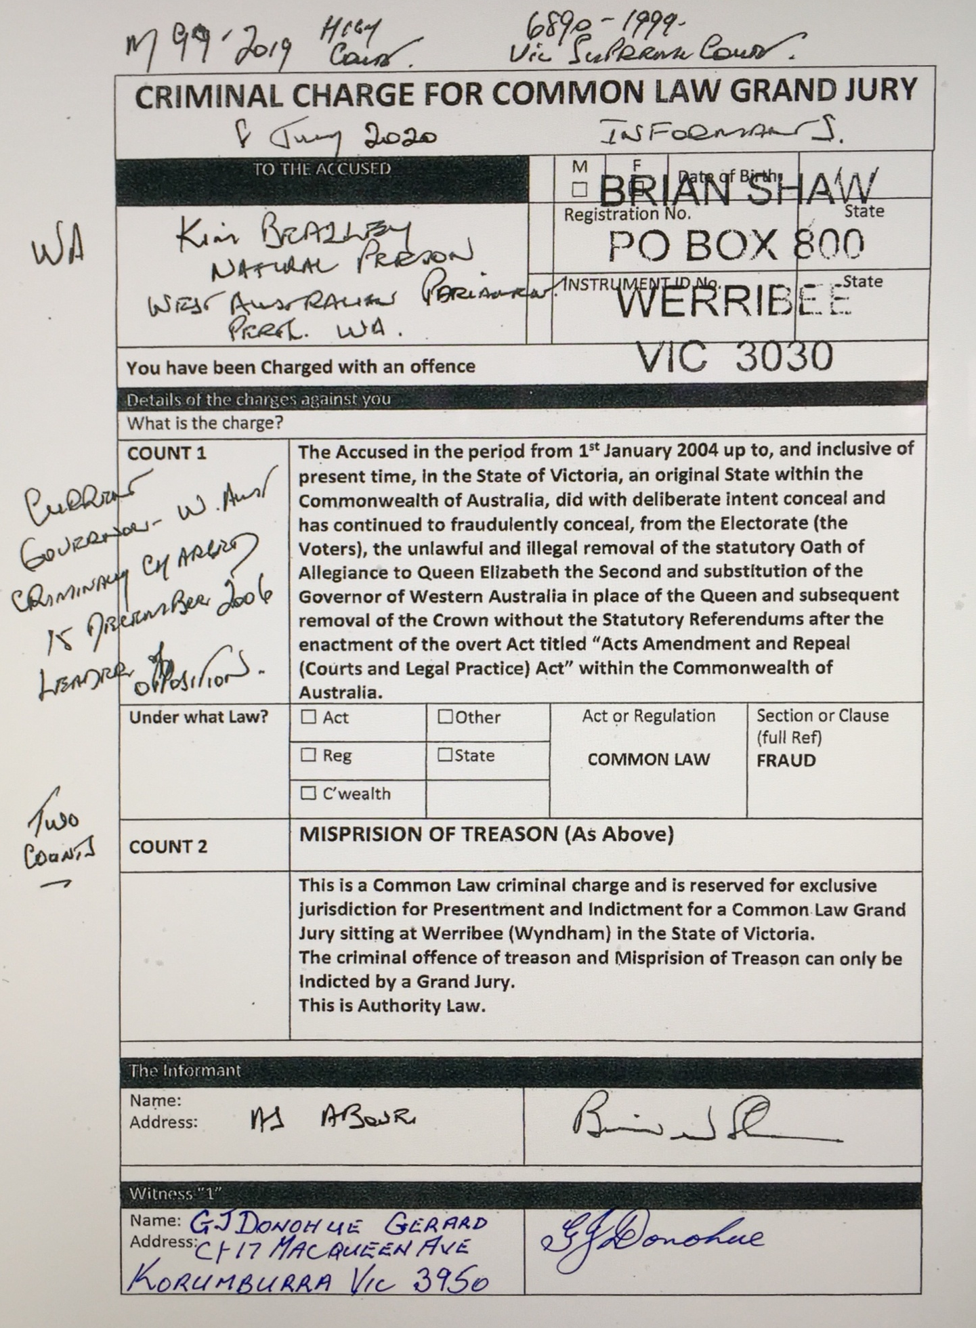
ANNEXURE C
Letters Patent re Constitution 25 August 1890 (UK)

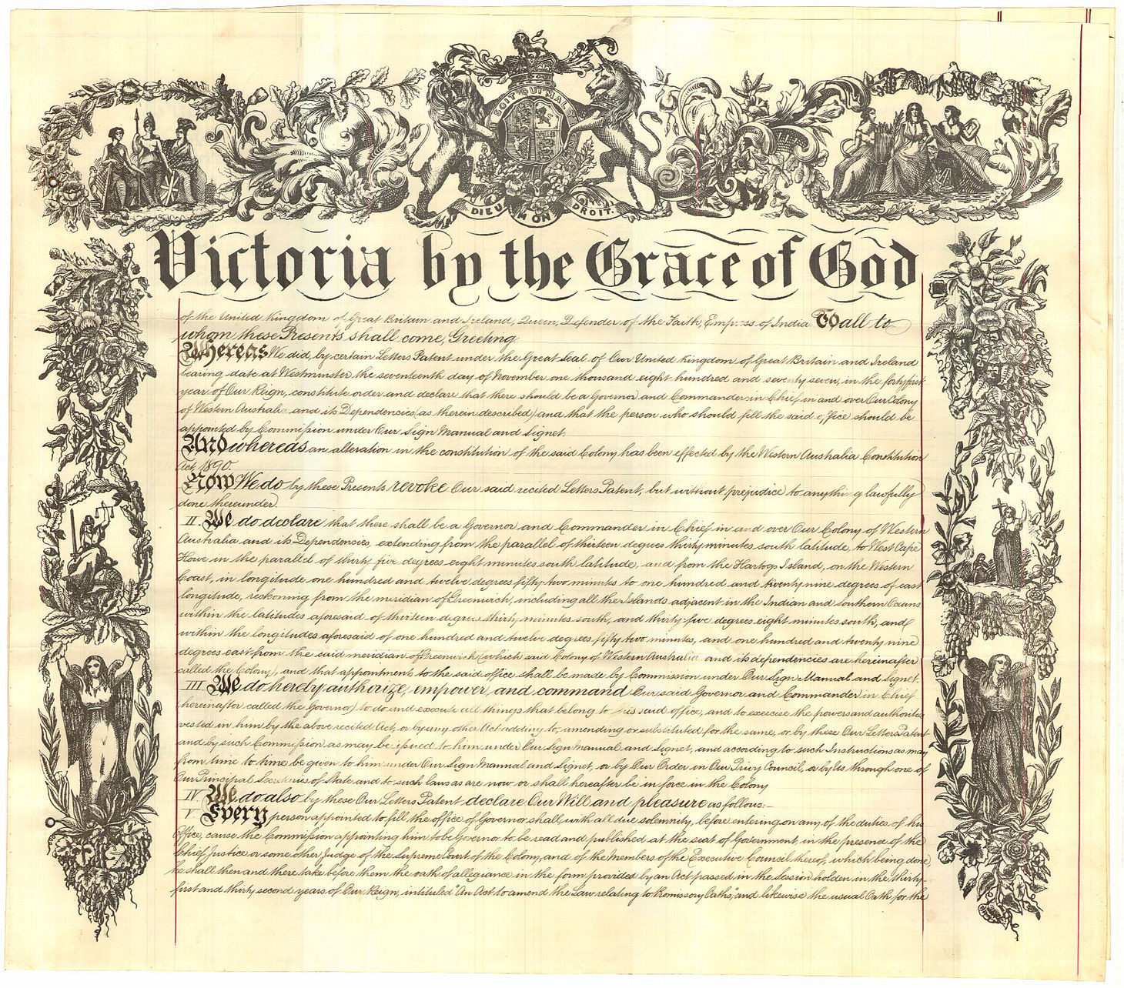

NOTE: original document handwritten on 6 pages. [PAGE ENDS HERE] signifies page ending of original document. <…….> signifies scope notes in small type in margin.

BEGIN TRANSCRIPTION Western Australia Letters Patent passed under the Great Seal of the United Kingdom, constituting the Office of Governor and Commander-in-Chief of the Colony of Western Australia and its Dependencies. (Dated 25th August 1890) Victoria, by the Grace of God of the United Kingdom of Great Britain and Ireland Queen, Defender of the Faith, Empress of India: To all to whom these Presents shall come, Greeting. Whereas we did, by certain Letters Patent under the Great Seal of Our United Kingdom of Great Britain and Ireland, bearing date at Westminster the Seventeenth day of November 1877, in the Forty-first year of Our Reign, constitute, order, and declare that there should be a Governor and Commander-in-Chief in and over Our Colony of Western Australia and its Dependancies (as therein described), and that the person who should fill the said office should be appointed by Commission under Our Sign Manual and Signet: And whereas an alteration in the Constitution of the said Colony has been effected by the Western Australia Constitution Act, 1890: Now we do by these presents revoke Our said recited Letters Patent, but without prejudice to anything lawfully done thereunder. Letters Patent constituting the Office of Governor and Commander-in-Chief of the Colony of Western Australia [DOCUMENT PAGE ONE ENDS HERE]

II. We do declare that there shall be a Governor and Commander-in-Chief in and over Our Colony of Western Australia and its Dependencies, extending from the parallel of thirteen degrees thirty minutes
south latitude, to West Cape Howe in the parallel of thirty-five degrees eight minutes south latitude, and from the Hartogs Island, on the Western Coast, in longitude one hundred and twelve degrees fiftytwo minutes to one hundred and twenty nine degrees of east longitude, reckoning from the meridian of Greenwich, including all the islands adjacent in the Indian and Southern Oceans within the latitudes aforesaid of thirteen degrees thirty minutes south, and thirty-five degrees eight minutes south, and within the longitudes aforesaid of one hundred and twelve degrees fifty-two minutes, and one hundred and twenty-nine degrees east from the said meridian of Greenwich (which said Colony of Western Australia and its Dependencies are herein-after called the Colony), and that appointments to the said office shall be made by Commission under Our Sign Manual and Signet.

III. We do hereby authorize, empower, and command Our said Governor and Commander-in- Letters Patent re Constitution 25 August 1890 (WA) Page 2 of 4 Chief (herein-after called the Governor) to do and execute all things that belong to his said office, and to exercise the powers and authorities vested in him by the above recited Act, or by any other Act adding to, amending, or substituted for the same, or by these our Letters Patent and by such Commission as may be issued to him under Our Sign Manual and Signet, and according to such Instructions as may be from time to time be given to him under Our Sign Manual and Signet, or by Our Order in Our Privy Council, or by Us through one of Our Principal Secretaries of State, and to such laws as are now or shall thereafter be in force in the Colony. [DOCUMENT PAGE TWO ENDS HERE]

IV. We do also by these Letters Patent declare Our Will and pleasue as follows:-

V. Every person appointed to fill the office of Governor shall, with all due solemnity, before entering on any of the duties of his office, cause the Commission appointing him to the Governor to be read and published at the seat of Government, in the presence of the Chief Justice or some other Judge of the Supreme Court of the Colony, and of the Members of the Executive Council thereof, which being done, he shall then and there take before them the Oath of Allegiance in the form provided by an Act passed in the Session holden in the Thirty-first and Thirty-second years of Our Reign, intituled “An Act to amend the Law relating to Promissory Oaths;” and likewise the usual Oath for the due execution of the office of Governor, and for the due and impartial administration of justice; which the Oaths the said Chief Justice or Judge is hereby required to administer.

VI. The Governor shall keep and use the Public Seal of the Colony for Sealing all things whatsoever that shall pass the said Public Seal.

VII. There shall be an Executive Council for the Colony, and the said Council shall consist of such persons as are now members thereof or may at any time be members thereof in accordance with any Law enacted by the Legislature of the Colony, and of such other persons as the Governor shall, from time to time, in Our name and on Our behalf, but subject to any Law as aforesaid, appoint under the Public Seal of the Colony to be Members of Our said Executive Council.

VIII. The Governor, in Our name and on Our behalf, may make and execute, under the said Public Seal, grants and dispositions of lands within [DOCUMENT PAGE THREE ENDS HERE] the Colony, subject to the laws in force for the time being for regulating the sale or disposal of Crown lands.

IX. The Governor may constitute and appoint, in Our name and on Our behalf, all such Judges, Commissioners, Justices of the Peace, and other necessary Officers and Ministers in the Colony, as may be lawfully constituted or appointed by Us. X. When any crime has been committed within the Colony, or for which the offender may be tried therein, the Governor may, as he shall see occasion, in Our name and on Our behalf, grant a pardon to any accomplice in such crime who shall give such information as shall lead to the conviction of the principal offender, or of any one of such offenders, if more than one; and further, may grant to any offender convicted in any Court, or Letters Patent re Constitution 25 August 1890 (WA) Page 3 of 4 before any Judge, or other Magistrate within the Colony, a pardon either free or subject to lawful conditions, or any remission of the sentence paased on such offender, or any respite of the execution of such sentence for such period as the Governor thinks fit; and further may

remit any fines, penalties, or forfeitures due or accrued to Us. Provided always that the Governor shall in no case, except where the offence has been of a political nature unaccompanied by any other grave

crime, make it a condition of any pardon or remission of sentence that the offender shall absent himself to be removed from the Colony.

XI. The Governor may, so far as We Ourselves lawfully may, upon sufficient cause to him appearing, remove from his office, or suspend from the exercise of the same, any person holding any office or place within the Colony, under or by [DOCUMENT PAGE FOUR ENDS HERE] virtue of any Commission or Warrant or other instrument granted, or which may be granted, by Us or in Our name, or under Our authority.

XII. The Governor may exercise all powers lawfully belonging to Us in respect of the summoning, proroguing, or dissolving any Legislative Body, which now is or hereafter may be established within the Colony, and in respect of the appointment of Members thereto.

XIII. In the event of the office of the Governor becoming vacant, or of the Governor being incapable, or of his departure from the Colony, Our Lieutenant Governor, or if there be no such Officer in the Colony, then such person or persons as We may appoint under Our Sign Manual and Signet, shall, during Our pleasure, administer the Government of the Colony, first taking the Oaths herein-before directed to be taken by the Governor and in the manner herein prescribed; which being done, We do hereby authorise, empower, and command Our Lieutenant Governor, and every other such Administrator as aforesaid, to do and execute, during Our pleasure, all things that belong to the office of Governor and Commander-inChief, according to the tenor of these Our Letters Patent, and according to Our Instructions as aforesaid, and the Laws of the Colony.

XIV. In the event of the Governor having occasion to be temporarily absent for a short period from the seat of Government or from the Colony, he may in every such case, by an Instrument under the Public Seal of the Colony, constitute and appoint Out Lieutenant Governor, or if there be no such Officer, then any other person, to be his Deputy during such temporary absence, and that capacity to exercise, perform, and execute for and on behalf of the Governor during such absence, but no longer, all such powers and authorities vested in the Governor by these Our Letters Patent, as shall in and by such Instrument be specified and limited, but no others. Provided, nevertheless, that by the appointment of a Deputy as aforesaid, the power and authority of the Governor shall not be abridged, altered, or in any way affected, otherwise than We may at any time hereafter think proper to direct.

XV. And We do hereby require and command all Our Officers and Ministers, Civil and Military, and all other inhabitants of the Colony, to be obedient, aiding, and assisting unto the Governor or to such person or persons as may from time to time, under the provisions of these Our Letters Patent, administer the Government of the Colony. Letters Patent re Constitution 25 August 1890 (WA) Page 4 of 4

XVI. And We do hereby reserve to Ourselves, Our heirs and successors, full power and authority from time to time to revoke, alter or amend these Our Letters Patent as to Us or shall seem meet.

XVII. And We do direct and enjoin that these Our Letters Patent shall be read and proclaimed at such place and places within Our said Colony as the Governor shall think fit. In witness whereof We have caused these Our Letters to be made Patent. Witness Ourself at Westminster, the twenty-fifth day of August, in the Fifty-fourth year of Our Reign. By Warrant under the Queen’s Sign Manual. Muir Mackenzie. END TRANSCRIPTION

https://www.foundingdocs.gov.au/resources/transcripts/wa8_doc_1890.pdf

